The company's migration plan states that only platform as a service (PaaS) solutions must be used in Azure.  
You need to deploy an Azure environment that supports the planned migration.  
Solution: You create an Azure App Service and Azure SQL databases.  
Does this meet the goal?

* A. Yes
* B. No

When planning to migrate a public website to Azure, you must plan to pay monthly usage costs.  
Instructions: Review the underlined text. If it makes the statement correct, select "No change is needed". If the statement is incorrect, select the answer choice that makes the statement correct.

* A. No change is needed
* B. Deploy a VPN
* C. pay to transfer all the website data to Azure
* D. reduce the number of connections to the website

What are two characteristics of the public cloud? Each correct answer presents a complete solution.  
NOTE: Each correct selection is worth one point.

* A. dedicated hardware
* B. unsecured connections
* C. limited storage
* D. metered pricing
* E. self-service management

An organization that hosts its infrastructure in a private cloud can decommission its data center.  
Instructions: Review the underlined text. If it makes the statement correct, select "No change is needed". If the statement is incorrect, select the answer choice that makes the statement correct.

* A. No change is needed.
* B. in a hybrid cloud
* C. in the public cloud
* D. on a Hyper-V host

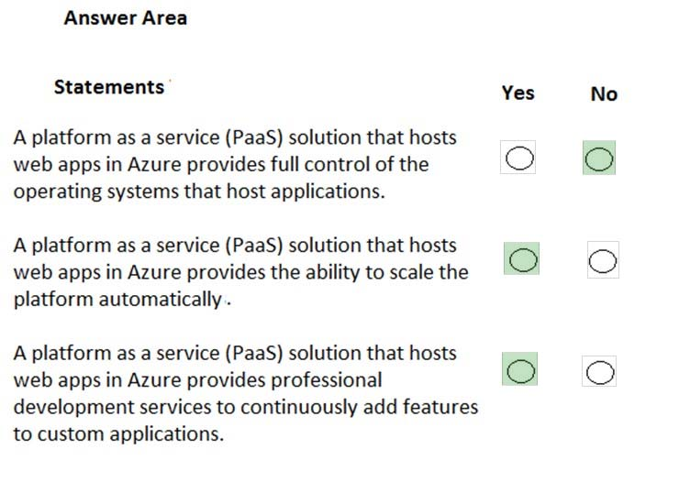

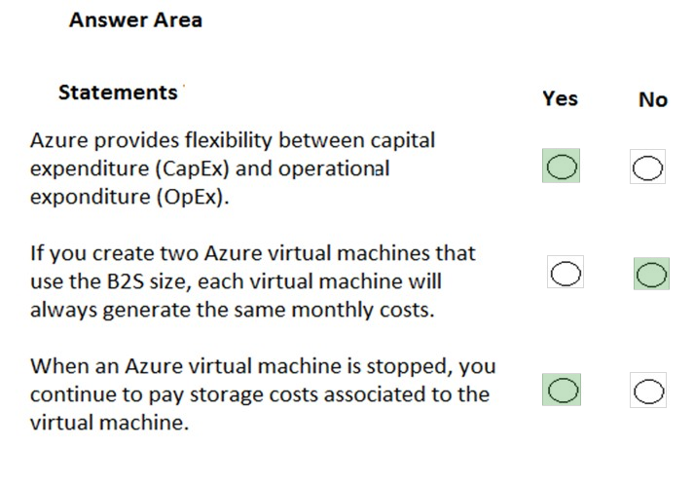

This question requires that you evaluate the underlined text to determine if it is correct.  
When you are implementing a software as a service (SaaS) solution, you are responsible for configuring high availability.  
Instructions: Review the underlined text. If it makes the statement correct, select "No change is needed". If the statement is incorrect, select the answer choice that makes the statement correct.

* A. No change is needed.
* B. defining scalability rules
* C. installing the SaaS solution
* D. configuring the SaaS solution

You have an on-premises network that contains several servers.  
You plan to migrate all the servers to Azure.  
You need to recommend a solution to ensure that some of the servers are available if a single Azure data center goes offline for an extended period.  
What should you include in the recommendation?

* A. fault tolerance
* B. elasticity
* C. scalability
* D. low latency

Your company plans to migrate all its data and resources to Azure.  
The company's migration plan states that only platform as a service (PaaS) solutions must be used in Azure.  
You need to deploy an Azure environment that supports the planned migration.  
Solution: You create an Azure App Service and Azure virtual machines that have Microsoft SQL Server installed.  
Does this meet the goal?

* A. Yes
* B. No

The company's migration plan states that only platform as a service (PaaS) solutions must be used in Azure.  
You need to deploy an Azure environment that supports the planned migration.  
Solution: You create an Azure App Service and Azure Storage accounts.  
Does this meet the goal?

* A. Yes
* B. No

Your company hosts an accounting named App1 that is used by all the customers of the company.  
App1 has low usage during the first three weeks of each month and very high usage during the last week of each month.  
Which benefit of Azure Cloud Services supports cost management for this type of usage pattern?

* A. high availability
* B. high latency
* C. elasticity
* D. load balancing

You plan to migrate a web application to Azure. The web application is accessed by external users.  
You need to recommend a cloud deployment solution to minimize the amount of administrative effort used to manage the web application.  
What should you include in the recommendation?

* A. software as a service (SaaS)
* B. platform as a service (PaaS)
* C. infrastructure as a service (IaaS)
* D. database as a service (DaaS)

Which cloud deployment solution is used for Azure virtual machines and Azure SQL databases? To answer, select the appropriate options in the answer area.

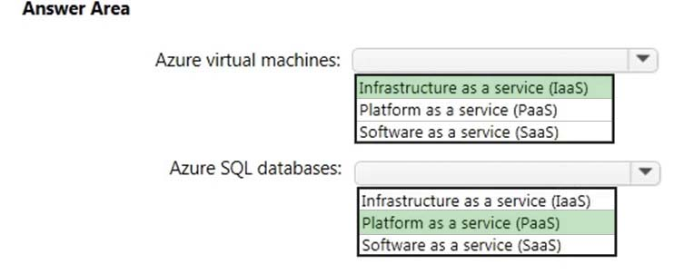

For each of the following statements, select Yes if the statement is true. Otherwise, select No.

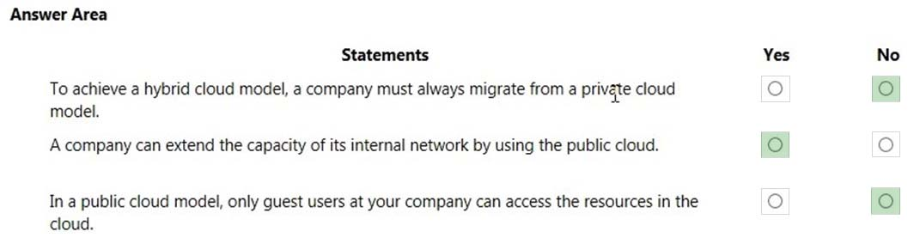

You plan to migrate several servers from an on-premises network to Azure.  
You need to identify the primary benefit of using a public cloud service for the servers.  
What should you identify?

* A. The public cloud is owned by the public, NOT a private corporation
* B. The public cloud is a crowd-sourcing solution that provides corporations with the ability to enhance the cloud
* C. All public cloud resources can be freely accessed by every member of the public
* D. The public cloud is a shared entity whereby multiple corporations each use a portion of the resources in the cloud

You need to ensure that the services running on the virtual machines are available if a single data center fails.  
Solution: You deploy the virtual machines to two or more scale sets.  
Does this meet the goal?

* A. Yes
* B. No

To move Azure VMs to an availability zone in a different region, we now recommend **using Azure Resource Mover**. Resource Mover is in public preview

You plan to deploy several Azure virtual machines.  
You need to ensure that the services running on the virtual machines are available if a single data center fails.  
Solution: You deploy the virtual machines to two or more availability zones.  
Does this meet the goal?

* A. Yes
* B. No

You have 1,000 virtual machines hosted on the Hyper-V hosts in a data center.  
You plan to migrate all the virtual machines to an Azure pay-as-you-go subscription.  
You need to identify which expenditure model to use for the planned Azure solution.  
Which expenditure model should you identify?

* A. operational
* B. elastic
* C. capital
* D. scalable
* You need to identify which administrative responsibilities will be eliminated after the planned migration.  
  Which two responsibilities should you identify? Each correct answer presents a complete solution.  
  NOTE: Each correct selection is worth one point.
* A. Replacing failed server hardware  
  B. Backing up application data  
  C. Managing physical server security  
  D. Updating server operating systems  
  E. Managing permissions to shared documents
  1. **Replacing failed server hardware  
     C. Managing physical server security**

You plan to deploy several Azure virtual machines.  
You need to ensure that the services running on the virtual machines are available if a single data center fails.  
Solution: You deploy the virtual machines to two or more regions.  
Does this meet the goal?

* A. Yes
* B. No

DRAG DROP -  
Match the Azure Cloud Services benefit to the correct description.

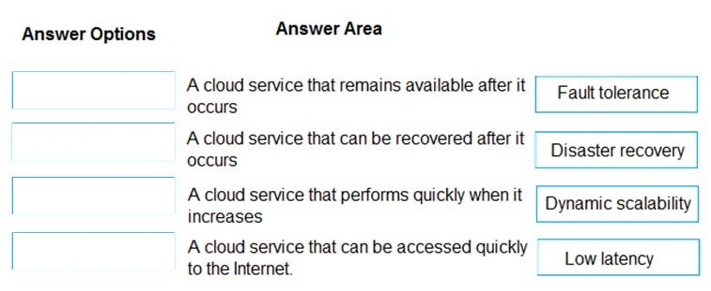

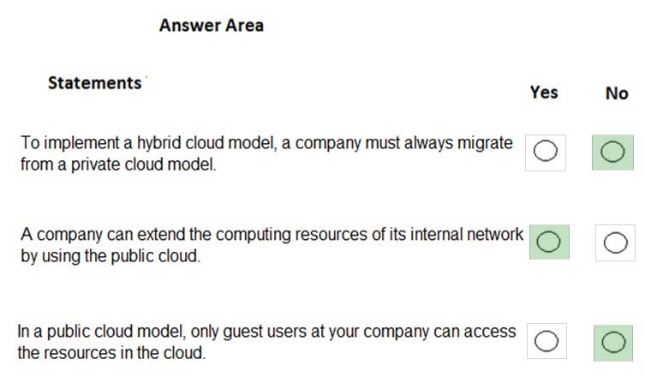

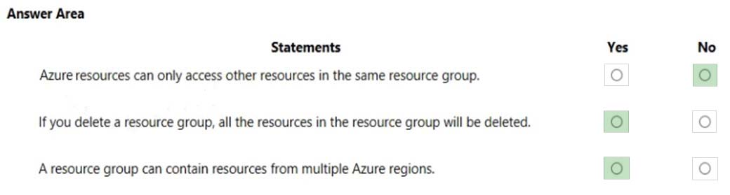

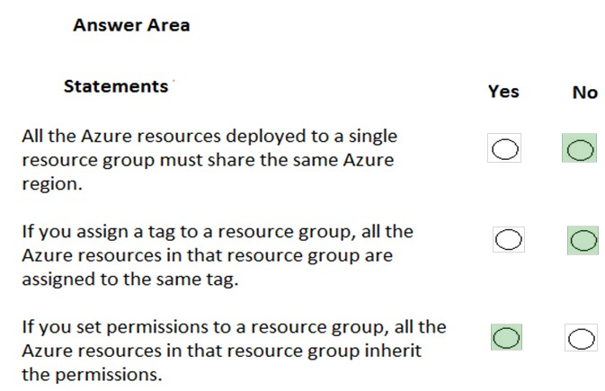

Your company plans to deploy an Artificial Intelligence (AI) solution in Azure.  
What should the company use to build, test, and deploy predictive analytics solutions?

* A. Azure Logic Apps
* B. Azure Machine Learning Studio
* C. Azure Batch
* D. Azure Cosmos DB

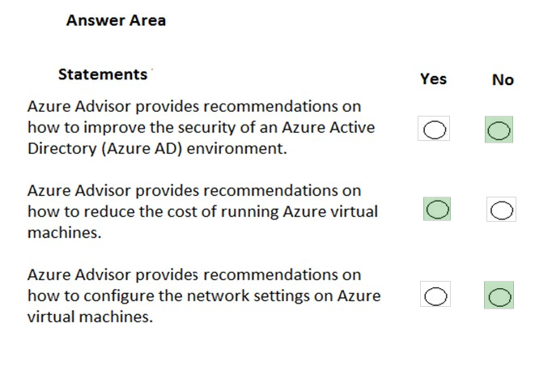

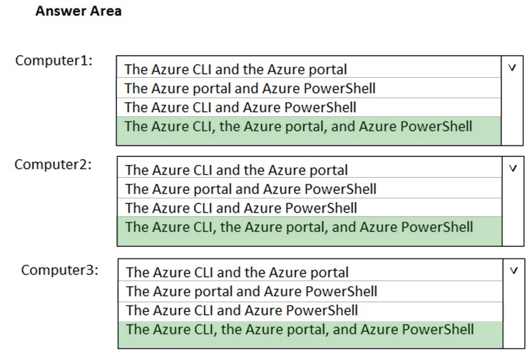

Azure policies provide a common platform for deploying objects to a cloud infrastructure and for implementing consistency across the Azure environment.  
Instructions: Review the underlined text. If it makes the statement correct, select "No change is needed". If the statement is incorrect, select the answer choice that makes the statement correct.

* A. No change is needed
* B. Resource groups provide
* C. Azure Resource Manager provides
* D. Management groups provide

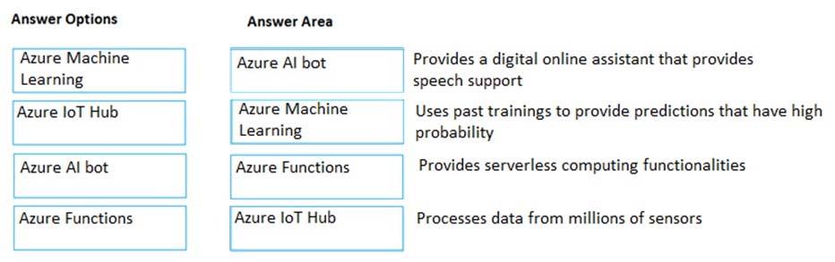

Each business unit requires 20 different Azure resources for daily operation. All the business units require the same type of Azure resources.  
You need to recommend a solution to automate the creation of the Azure resources.  
What should you include in the recommendations?

* A. Azure Resource Manager templates
* B. virtual machine scale sets
* C. the Azure API Management service
* D. management groups

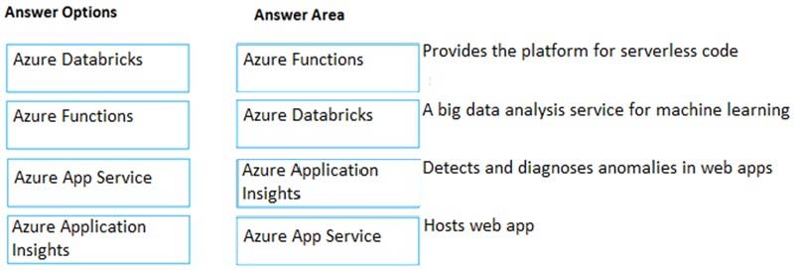

The application will run on an Azure virtual machine.  
You need to recommend a deployment solution for the application. The solution must provide a guaranteed availability of 99.99 percent.  
What is the minimum number of virtual machines and the minimum number of availability zones you should recommend for the deployment? To answer, select the appropriate options in the answer area.

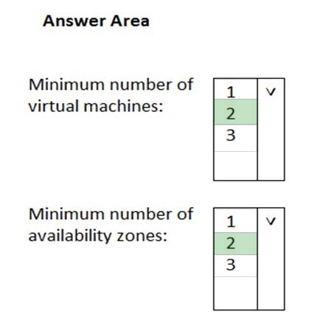

Which Azure service should you use to correlate events from multiple resources into a centralized repository?

* A. Azure Event Hubs
* B. Azure Analysis Services
* C. Azure Monitor
* D. Azure Log Analytics

You have an Azure environment. You need to create a new Azure virtual machine from an Android laptop.  
Solution: You use the PowerApps portal.  
Does this meet the goal?

* A. Yes
* B. No

You have an Azure environment. You need to create a new Azure virtual machine from an Android laptop.  
Solution: You use the Azure portal.  
Does this meet the goal?

* A. Yes
* B. No

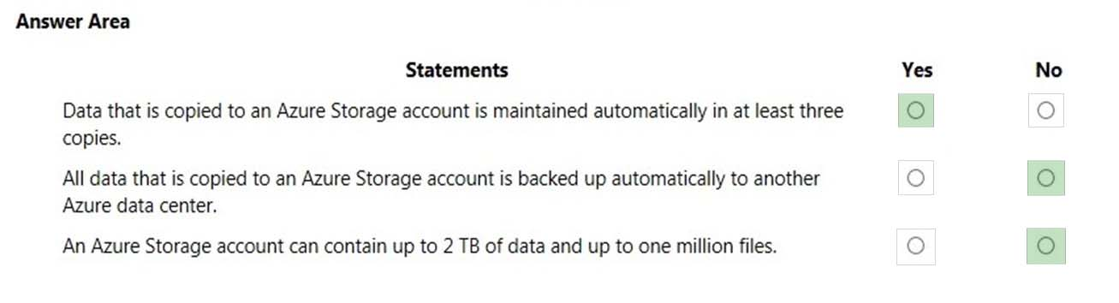

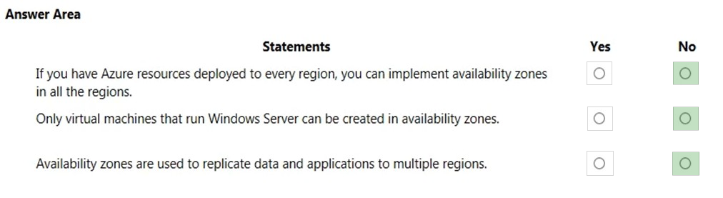

An Azure region contains one or more data centers that are connected by using a low-latency network.  
the statement is incorrect, select the answer choice that makes the statement correct.

* A. No change is needed
* B. Is found in each country where Microsoft has a subsidiary office
* C. Can be found in every country in Europe and the Americas only
* D. Contains one or more data centers that are connect by using a high-latency network

This question requires that you evaluate the underlined text to determine if it is correct.  
You plan to deploy 20 virtual machines to an Azure environment. To ensure that a virtual machine named VM1 cannot connect to the other virtual machines, VM1 must be deployed to a separate virtual network.  
A. No change is needed

* B. run a different operating system than the other virtual machines
* C. be deployed to a separate resource group
* D. have two network interfaces

When you need to delegate permissions to several Azure virtual machines simultaneously, you must deploy the Azure virtual machines to the same Azure region.

* A. No change is needed
* B. by using the same Azure Resource Manager template
* C. to the same resource group
* D. to the same availability zone

 team of developers at your company plans to deploy, and then remove, 50 customized virtual machines each week. Thirty of the virtual machines run Windows  
Server 2016 and 20 of the virtual machines run Ubuntu Linux.  
You need to recommend which Azure service will minimize the administrative effort required to deploy and remove the virtual machines.  
What should you recommend?

* A. Azure Reserved Virtual Machines (VM) Instances
* B. Azure virtual machine scale sets
* C. Azure DevTest Labs
* D. Microsoft Managed Desktop

A support engineer plans to perform several Azure management tasks by using the Azure CLI.  
You install the CLI on a computer.  
You need to tell the support engineer which tools to use to run the CLI.  
Which two tools should you instruct the support engineer to use? Each correct answer presents a complete solution.  
NOTE: Each correct selection is worth one point.

* A. Command Prompt
* B. Azure Resource Explorer
* C. Windows PowerShell
* D. Windows Defender Firewall
* E. Network and Sharing Center

This question requires that you evaluate the underlined text to determine if it is correct.  
One of the benefits of Azure SQL Data Warehouse is that high availability is built into the platform.  
Instructions: Review the underlined text. If it makes the statement correct, select "No change is needed". If the statement is incorrect, select the answer choice that makes the statement correct.

* A. No change is needed
* B. automatic scaling
* C. data compression
* D. versioning

You need to identify the type of failure for which an Azure availability zone can be used to protect access to Azure services.  
What should you identify?

* A. a physical server failure
* B. an Azure region failure
* C. a storage failure
* D. an Azure data center failure

You plan to extend your company's network to Azure. The network contains a VPN appliance that uses an IP address of 131.107.200.1.  
You need to create an Azure resource that identifies the VPN appliance

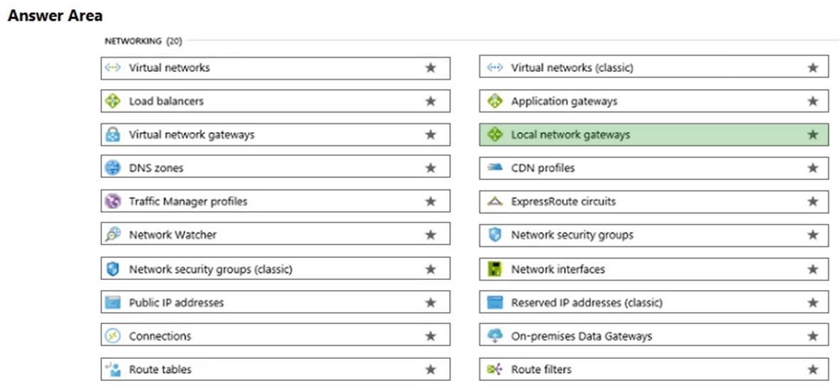

You have a virtual machine named VM1 that runs Windows Server 2016. VM1 is in the East US Azure region.  
Which Azure service should you use from the Azure portal to view service failure notifications that can affect the availability of VM1?

* A. Azure Service Fabric
* B. Azure Monitor
* C. Azure virtual machines
* D. Azure Advisor

An Azure administrator plans to run a PowerShell script that creates Azure resources.  
You need to recommend which computer configuration to use to run the script.  
Solution: Run the script from a computer that runs Linux and has the Azure CLI tools installed.  
Does this meet the goal?

* A. Yes
* B. No

An Azure administrator plans to run a PowerShell script that creates Azure resources.  
You need to recommend which computer configuration to use to run the script.  
Solution: Run the script from a computer that runs Chrome OS and uses Azure Cloud Shell.  
Does this meet the goal?

* A. Yes
* B. No

An Azure administrator plans to run a PowerShell script that creates Azure resources.  
You need to recommend which computer configuration to use to run the script.  
Solution: Run the script from a computer that runs macOS and has PowerShell Core 6.0 installed.  
Does this meet the goal?

* A. Yes
* B. No

You have an Azure environment that contains 10 virtual networks and 100 virtual machines.  
You need to limit the amount of inbound traffic to all the Azure virtual networks.  
What should you create?

* A. one network security group (NSG)
* B. 10 virtual network gateways
* C. 10 Azure ExpressRoute circuits
* D. one Azure firewall

You need to view a list of planned maintenance events that can affect the availability of an Azure subscription.

Which blade should you use from the Azure portal? Ans – Help -support

Answers

* A. Advisor
* B. Security Center
* C. Cost Management + Billing
* D. Help + support

Q/A

An integrated solution for the deployment of code - **Azure DevOps**

A tool that provides guidance and recommendation to improve an Azure environment - **Azure Advisor**

A simplified tool to build intelligent Artificial Intelligence (AI) applications - **Azure Cognitive services**

Monitors web applications - **Azure Application Insights**

You have an Azure environment that contains multiple Azure virtual machines.  
You plan to implement a solution that enables the client computers on your on-premises network to communicate to the Azure virtual machines.

* A. a virtual network gateway
* B. a load balancer
* C. an application gateway
* D. a virtual network
* E. a gateway subnet

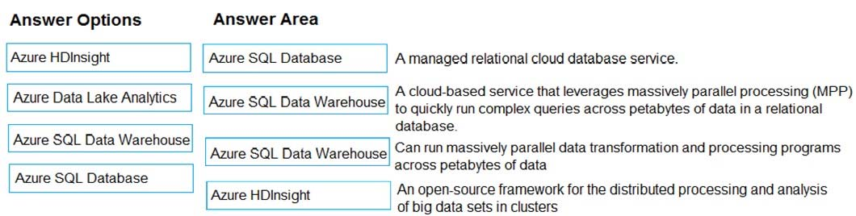

3rd is data lake analytics

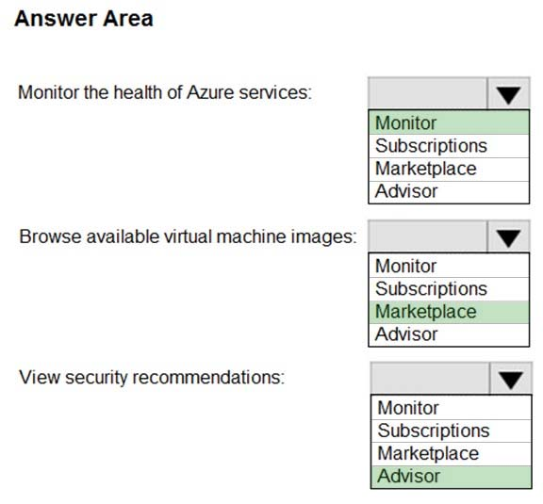

After you answer a question in this section, you will NOT be able to return to it. As a result, these questions will not appear in the review screen.  
You have an Azure environment. You need to create a new Azure virtual machine from a tablet that runs the Android operating system.  
Solution: You use Bash in Azure Cloud Shell.  
Does this meet the goal?

* **A.**Yes
* **B.**No

Expose Correct Answer

Answer : **A**

You plan to create an Azure virtual machine.  
You need to identify which storage service must be used to store the unmanaged data disks of the virtual machine.  
What should you identify? To answer, select the appropriate service in the answer area.  
Hot Area:

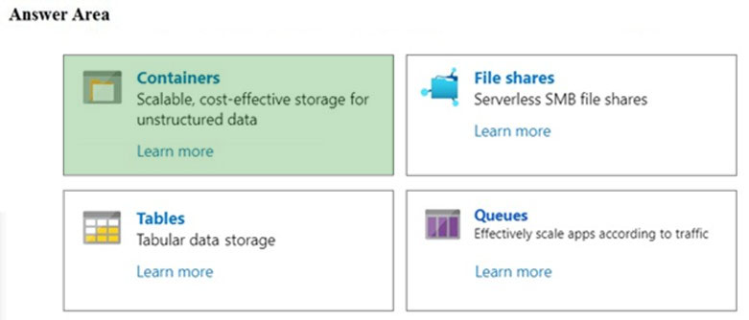

Your company plans to move several servers to Azure.  
The company's compliance policy states that a server named FinServer must be on a separate network segment.  
You are evaluating which Azure services can be used to meet the compliance policy requirements.  
Which Azure solution should you recommend?

* A. a resource group for FinServer and another resource group for all the other servers
* B. a virtual network for FinServer and another virtual network for all the other servers
* C. a VPN for FinServer and a virtual network gateway for each other server
* D. one resource group for all the servers and a resource lock for FinServer

Your company plans to migrate all its network resources to Azure.  
You need to start the planning process by exploring Azure.  
What should you create first?

* A. a subscription

You have an on-premises application that sends email notifications automatically based on a rule.  
You plan to migrate the application to Azure.  
You need to recommend a serverless computing solution for the application.  
What should you include in the recommendation?

* A. a web app
* B. a server image in Azure Marketplace
* C. a logic app
* D. an API app

You plan to deploy a website to Azure. The website will be accessed by users worldwide and will host large video files.  
You need to recommend which Azure feature must be used to provide the best video playback experience.  
What should you recommend?

* **A.**an application gateway
* **B.**an Azure ExpressRoute circuit
* **C.**a content delivery network (CDN)
* **D.**an Azure Traffic Manager profile

Expose Correct Answer

Answer : **C**

Explanation:  
The question states that users are located worldwide and will be downloading large video files. The video playback experience would be improved if they can download the video from servers in the same region as the users. We can achieve this by using a content deliver network

you have an Azure web app.  
You need to manage the settings of the web app from an iPhone.  
What are two Azure management tools that you can use? Each correct answer presents a complete solution.  
NOTE: Each correct selection is worth one point.

* **A.**Azure CLI
* **B.**the Azure portal
* **C.**Azure Cloud Shell
* **D.**Windows PowerShell
* **E.**Azure Storage Explorer

Expose Correct Answer

Answer : **BC**

Explanation:  
The Azure portal is the web-based portal for managing Azure. Being web-based, you can use the Azure portal on an iPhone.

our company plans to deploy several million sensors that will upload data to Azure.  
You need to identify which Azure resources must be created to support the planned solution.  
Which two Azure resources should you identify? Each correct answer presents part of the solution.  
NOTE: Each correct selection is worth one point.

* **A.**Azure Data Lake
* **B.**Azure Queue storage
* **C.**Azure File Storage
* **D.**Azure IoT Hub
* **E.**Azure Notification Hubs

Expose Correct Answer

Answer : **AD**

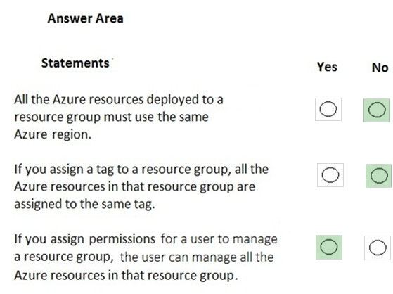

If a resource group named RG1 has a delete lock, only a member of the global administrators group can delete RG1

* A. No change is needed
* B. the delete lock must be removed before an administrator
* C. an Azure policy must be modified before an administrator
* D. an Azure tag must be added before an administrator

Azure Germany can be used by legal residents of Germany only.  
Instructions: Review the underlined text. If it makes the statement correct, select "No change is needed". If the statement is incorrect, select the answer choice that makes the statement correct.

* A. no change is needed
* B. only enterprises that are registered in Germany
* C. only enterprises that purchase their azure licenses from a partner based in Germany
* D. any user or enterprise that requires its data to reside in Germany

After you create a virtual machine, you need to modify the network security group (NSG) to allow connections from TCP port 8080 to the virtual machine.  
Instructions: Review the underlined text. If it makes the statement correct, select "No change is needed". If the statement is incorrect, select the answer choice that makes the statement correct.

* A. No change is needed
* B. virtual network gateway
* C. virtual network
* D. route table

Your Azure environment contains multiple Azure virtual machines.  
You need to ensure that a virtual machine named VM1 is accessible from the Internet over HTTP.  
Solution: You modify a DDoS protection plan.  
Does this meet the goal?

* A. Yes
* B. No

You need to ensure that a virtual machine named VM1 is accessible from the Internet over HTTP.  
Solution: You modify an Azure firewall.  
Does this meet the goal?

* A. Yes
* B. No

Your Azure environment contains multiple Azure virtual machines.  
You need to ensure that a virtual machine named VM1 is accessible from the Internet over HTTP.  
Solution: You modify an Azure Traffic Manager profile.  
Does this meet the goal?

* A. Yes
* B. No

Which two types of customers are eligible to use Azure Government to develop a cloud solution? Each correct answer presents a complete solution.  
NOTE: Each correct selection is worth one point.

* A. a Canadian government contractor
* B. a European government contractor
* C. a United States government entity
* D. a United States government contractor
* E. a European government entity

To implement an Azure Multi-Factor Authentication(MFA) solution, you must deploy a federation solution or sync on-premises identities to the cloud-->**NO**

Two valid methods for Azure Multi-Factor Authentication (MFA) are picture identification and a passport number-->**NO**

Azure Multi-Factor Authentication (MFA) can be required for administrative and non-administrative user accounts--> **YES**

Azure AD Identity Protection "Identity Protection is a tool that allows organizations to accomplish three key tasks: Automate the detection and remediation of identity-based risks. Investigate risks using data in the portal. Export risk detection data to third-party utilities for further analysis."

You need to ensure that when Azure Active Directory (Azure AD) users connect to Azure AD from the Internet by using an anonymous IP address, the users are prompted automatically to change their password.  
Which Azure service should you use?

* A. Azure AD Connect Health
* B. Azure AD Privileged Identity Management
* C. Azure Advanced Threat Protection (ATP)
* D. Azure AD Identity Protection

An organization that defines all international standards across all industries -**ISO**

*An organization that defines the standards used by the US govt -**NIST**

*An European policy that defines data privacy & protection- **GDPR**

*A dedicated public cloud for federal/state agencies in the **US- Azure Government**

Your company plans to deploy several web servers and several database servers to Azure.  
You need to recommend an Azure solution to limit the types of connections from the web servers to the database servers.  
What should you include in the recommendation?

* A. network security groups (NSGs)
* B. Azure Service Bus
* C. a local network gateway
* D. a route filter

To what should an application connect to retrieve security tokens?

* A. an Azure Storage account
* B. Azure Active Directory (Azure AD)
* C. a certificate store
* D. an Azure key vault

Resource groups provide organizations with the ability to manage the compliance of Azure resources across multiple subscriptions.  
Instructions: Review the underlined text. If it makes the statement correct, select "No change is needed". If the statement is incorrect, select the answer choice that makes the statement correct.

* A. No change is needed
* B. Management groups
* C. Azure policies
* D. Azure App Service plans

Your network contains an Active Directory forest. The forest contains 5,000 user accounts.  
Your company plans to migrate all network resources to Azure and to decommission the on-premises data center.  
You need to recommend a solution to minimize the impact on users after the planned migration.  
What should you recommend?

* A. Implement Azure Multi-Factor Authentication (MFA)
* B. Sync all the Active Directory user accounts to Azure Active Directory (Azure AD)
* C. Instruct all users to change their password
* D. Create a guest user account in Azure Active Directory (Azure AD) for each user

Which Azure service should you use to store certificates?

* A. Azure Security Center
* B. an Azure Storage account
* C. Azure Key Vault
* D. Azure Information Protection

You have a resource group named RG1.  
You plan to create virtual networks and app services in RG1.  
You need to prevent the creation of virtual machines only in RG1.  
What should you use?

* A. a lock
* B. an Azure role
* C. a tag
* D. an Azure policy

What can Azure Information Protection encrypt?

* A. network traffic
* B. documents and email messages
* C. an Azure Storage account
* D. an Azure SQL database

What should you use to evaluate whether your company's Azure environment meets regulatory requirements?

* A. the Knowledge Center website
* B. the Advisor blade from the Azure portal
* C. Compliance Manager from the Security Trust Portal
* D. the Security Center blade from the Azure portal

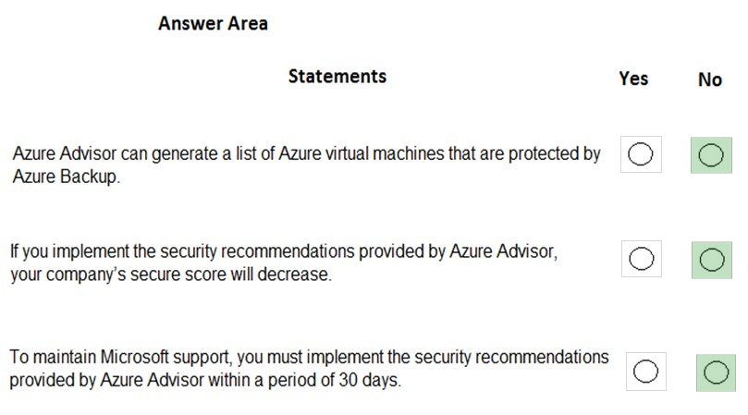

Your company implements Azure policies to automatically add a watermark to Microsoft Word documents that contain credit card information.  
Instructions: Review the underlined text. If it makes the statement correct, select "No change is needed". If the statement is incorrect, select the answer choice that makes the statement correct.

* A. No change is needed.
* B. DDoS protection
* C. Azure Information Protection
* D. Azure Active Directory (Azure AD) Identity Protection

From Azure Monitor, you can view which user turned off a specific virtual machine during the last 14 days.  
Instructions: Review the underlined text. If it makes the statement correct, select "No change is needed". If the statement is incorrect, select the answer choice that makes the statement correct.

* A. No change is needed
* B. Azure Event Hubs
* C. Azure Activity Log
* D. Azure Service Health

You have an Azure virtual network named VNET1 in a resource group named RG1.  
You assign an Azure policy specifying that virtual networks are not an allowed resource type in RG1. VNET1 is deleted automatically.  
Instructions: Review the underlined text. If it makes the statement correct, select "No change is needed". If the statement is incorrect, select the answer choice that makes the statement correct.

* A. No change is needed
* B. is moved automatically to another resource group
* C. continues to function normally
* D. is now a read-only object

C Is Correct

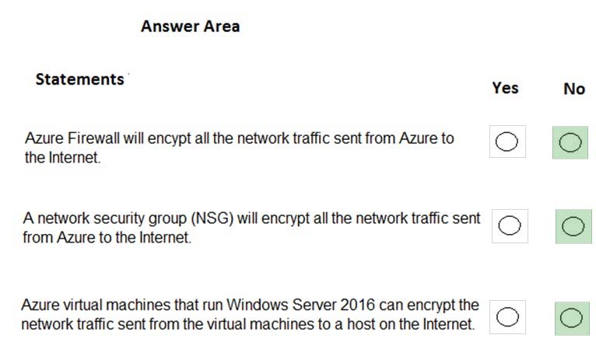

Your company has an Azure environment that contains resources in several regions.  
A company policy states that administrators must only be allowed to create additional Azure resources in a region in the country where their office is located.  
You need to create the Azure resource that must be used to meet the policy requirement.  
What should you create?

* A. a read-only lock
* B. an Azure policy
* C. a management group
* D. a reservation

Authorization is the process of verifying a user's credentials.  
Instructions: Review the underlined text. If it makes the statement correct, select "No change is needed". If the statement is incorrect, select the answer choice that makes the statement correct.

* A. No change is needed
* B. Authentication
* C. Federation
* D. Ticketing

You need to configure an Azure solution that meets the following requirements:  
✑ Secures websites from attacks  
✑ Generates reports that contain details of attempted attacks  
What should you include in the solution?

* A. Azure Firewall
* B. a network security group (NSG)
* C. Azure Information Protection
* D. DDoS protection

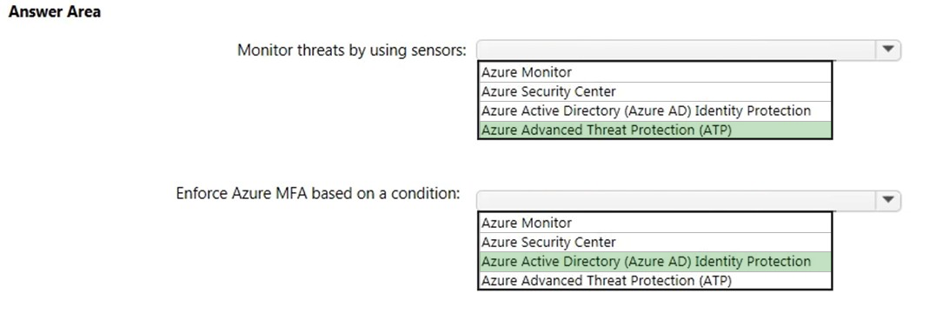

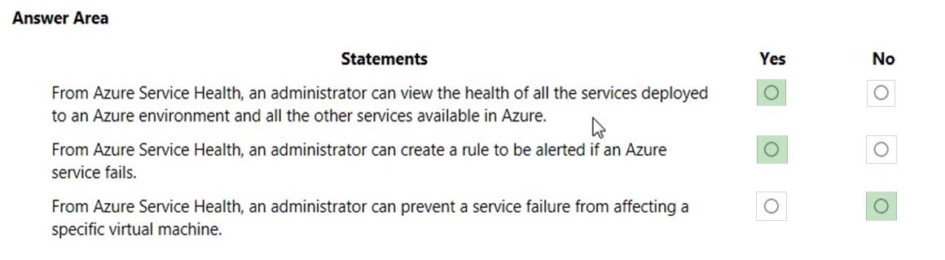

Your company plans to migrate all on-premises data to Azure. You need to identify whether Azure complies with the company's regional requirements.  
What should you use?

* A. the Knowledge Center
* B. Azure Marketplace
* C. the Azure portal
* D. the Trust Center

Azure Key Vault is used to store secrets for Azure Active Directory (Azure AD) user accounts.  
Instructions: Review the underlined text. If it makes the statement correct, select "No change is needed". If the statement is incorrect, select the answer choice that makes the statement correct.

* A. No change is needed
* B. Azure Active Directory (Azure AD) administrative accounts
* C. Personally Identifiable Information (PII)
* D. server applications

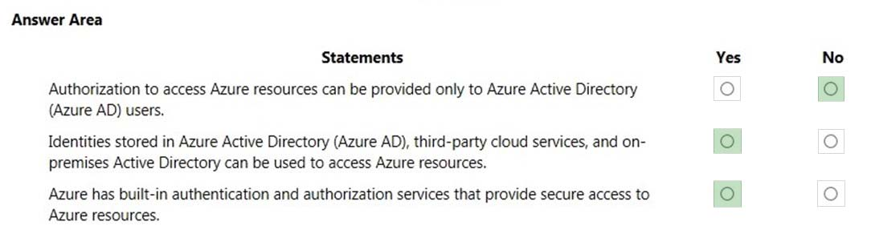

Your company plans to automate the deployment of servers to Azure.  
Your manager is concerned that you may expose administrative credentials during the deployment.  
You need to recommend an Azure solution that encrypts the administrative credentials during the deployment.  
What should you include in the recommendation?

* A. Azure Key Vault
* B. Azure Information Protection
* C. Azure Security Center
* D. Azure Multi-Factor Authentication (MFA)

You plan to deploy several Azure virtual machines.  
You need to control the ports that devices on the Internet can use to access the virtual machines.  
What should you use?

* A. a network security group (NSG)
* B. an Azure Active Directory (Azure AD) role
* C. an Azure Active Directory group
* D. an Azure key vault

This question requires that you evaluate the underlined text to determine if it is correct.  
You have several virtual machines in an Azure subscription. You create a new subscription. The virtual machines cannot be moved to the new subscription.  
Instructions: Review the underlined text. If it makes the statement correct, select "No change is needed". If the statement is incorrect, select the answer choice that makes the statement correct.

* A. No change is needed
* B. The virtual machines can be moved to the new subscription
* C. The virtual machines can be moved to the new subscription only if they are all in the same resource group
* D. The virtual machines can be moved to the new subscription only if they run Windows Server 2016.

You attempt to create several managed Microsoft SQL Server instances in an Azure environment and receive a message that you must increase your Azure subscription limits.  
What should you do to increase the limits?

* A. Create a service health alert
* B. Upgrade your support plan
* C. Modify an Azure policy
* D. Create a new support request

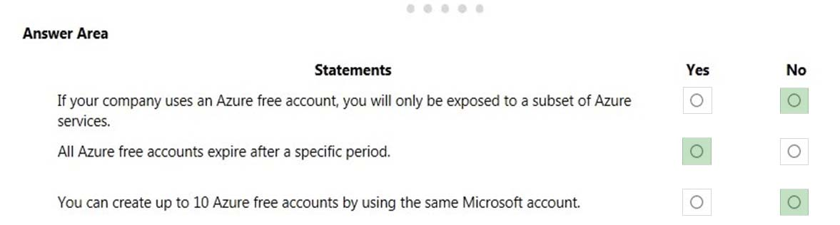

---------------------------------------------------------------------------------------------------------------- 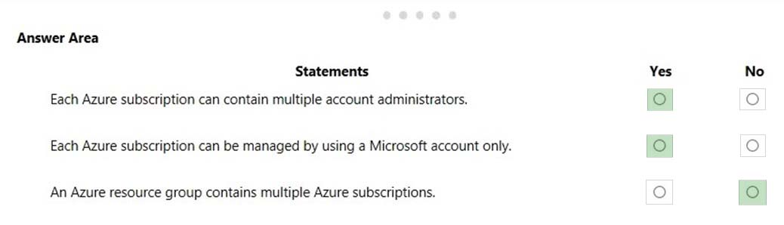

Your company has 10 offices. You plan to generate several billing reports from the Azure portal. Each report will contain the Azure resource utilization of each office.  
Which Azure Resource Manager feature should you use before you generate the reports?

* A. tags
* B. templates
* C. locks
* D. policies

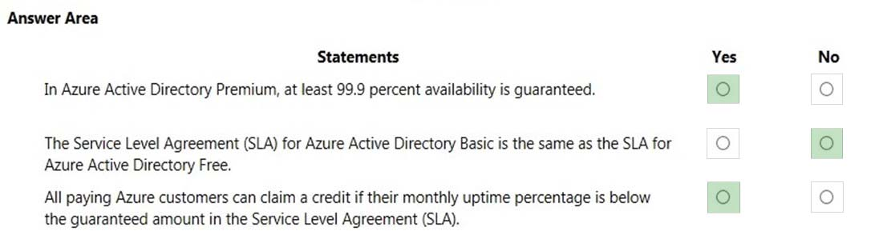

This question requires that you evaluate the underlined text to determine if it is correct.  
You deploy an Azure resource. The resource becomes unavailable for an extended period due to a service outage. Microsoft will automatically refund your bank account.  
Instructions: Review the underlined text. If it makes the statement correct, select "No change is needed". If the statement is incorrect, select the answer choice that makes the statement correct.

* A. No change is needed.
* B. automatically migrate the resource to another subscription
* C. automatically credit your account
* D. send you a coupon code that you can redeem for Azure credits

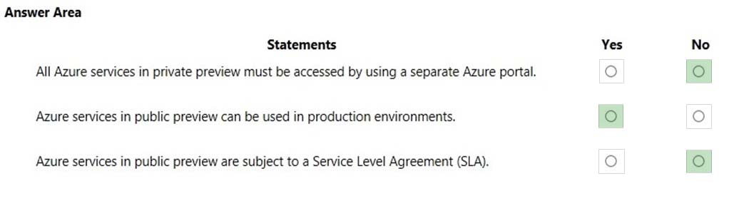

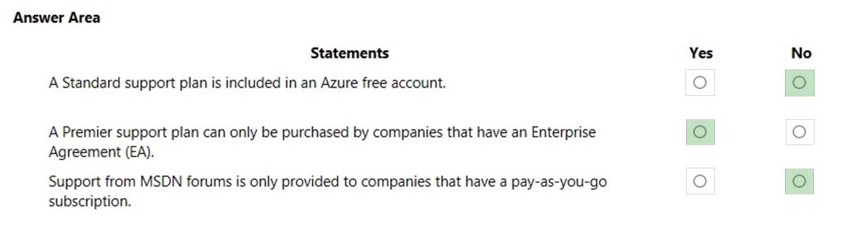

Your company plans to migrate to Azure. The company has several departments. All the Azure resources used by each department will be managed by a department administrator.  
You need to recommend an Azure deployment that provides the ability to segment Azure for the departments. The solution must minimize administrative effort.  
What should you include in the recommendation?

* A. multiple subscriptions
* B. multiple Azure Active Directory (Azure AD) directories
* C. multiple regions
* D. multiple resource groups

Your company has an Azure subscription that contains the following unused resources:  
✑ 20 user accounts in Azure Active Directory (Azure AD)  
✑ Five groups in Azure AD  
✑ 10 public IP addresses  
✑ 10 network interfaces  
You need to reduce the Azure costs for the company.  
Solution: You remove the unused network interfaces.  
Does this meet the goal?

* A. Yes
* B. No

Your company has an Azure subscription that contains the following unused resources:  
✑ 20 user accounts in Azure Active Directory (Azure AD)  
✑ Five groups in Azure AD  
✑ 10 public IP addresses  
✑ 10 network interfaces  
You need to reduce the Azure costs for the company.  
Solution: You remove the unused public IP addresses.  
Does this meet the goal?

* A. Yes
* B. No

your company has an Azure subscription that contains the following unused resources:  
✑ 20 user accounts in Azure Active Directory (Azure AD)  
✑ Five groups in Azure AD  
✑ 10 public IP addresses  
✑ 10 network interfaces  
You need to reduce the Azure costs for the company.  
Solution: You remove the unused user accounts.  
Does this meet the goal?

* A. Yes
* B. No

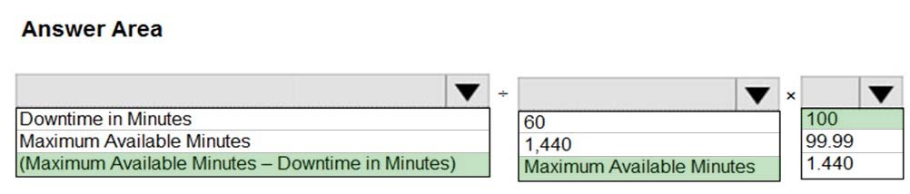

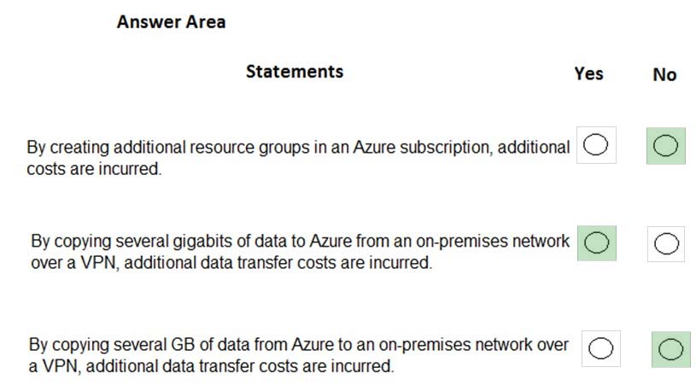

Which of the following statements is *not* true about cloud computing?



IaaS, PaaS, and SaaS are examples of cloud computing service models.



Cloud computing resources are usually limited to specific geographic regions.

Most cloud computing resources can be distributed to global datacenters.



Cloud computing typically decreases your operating expenses.



Three cloud computing deployment models are public cloud, private cloud, and hybrid cloud.

2.

True or false: You need to purchase an Azure account before you can use any Azure resources.



False

You can use a free Azure account or a Microsoft Learn sandbox to create resources.



True

3.

True or false: In an IaaS environment, the cloud tenant is responsible for routine hardware maintenance.



True



False

In an IaaS environment, the cloud provider is responsible for any hardware maintenance.